Date: 19/11/2024
Roll No. and Name: 24ITC087 Khush Pithva
Course Code and Name: 2CS101 Computer Programming

Practical No: 8(a)
Aim:Create a structure which holds various attributes (e.g., name, id, basic_salary, DA%, HRA%, total_salary etc.) of an employee. Write a program which allows you to scan these (except total_salary) attributes for 3 employees. The program should support following operations: i.Display (total salary of the selected employee) ii.Max (find and display name of the employee with maximum salary)

Methodology Followed:
#include<stdio.h>
#include<string.h>

struct employee {
char name[50];
int id;
float bas_sal;
float da;
float hra;
double tot_sal;
};

int main() {
struct employee e[3];
printf("Enter details for 3 employees:\n");

for (int i = 0; i < 3; i++) {
printf("\nEmployee %d:\n", i + 1);
printf("Enter Name: ");
scanf(" %[^\n]", e[i].name);
printf("Enter ID: ");
scanf("%d", &e[i].id);
printf("Enter Basic Salary: ");
scanf("%f", &e[i].bas_sal);
printf("Enter DA percentage: ");
scanf("%f", &e[i].da);
printf("Enter HRA percentage: ");
scanf("%f", &e[i].hra);
}

// Calculate total salary
for (int i = 0; i < 3; i++) {
float da = (e[i].bas_sal * e[i].da) / 100;
float hra = (e[i].bas_sal * e[i].hra) / 100;
e[i].tot_sal = e[i].bas_sal + da + hra;
}

int choice;
printf("\nEnter your choice:\n1. Display Employee Details\n2. Display Employee with Maximum Salary\n");
scanf("%d", &choice);
int i;

switch (choice) {
case 1:
printf("\n Enter employee number you wanna see");
scanf("%d",&i);
switch (i);

printf("\nEmployee %d:\n", i + 1);
printf("Name: %s\n", e[i].name);
printf("ID: %d\n", e[i].id);
printf("Basic Salary: %.2f\n", e[i].bas_sal);
printf("DA Percentage: %.2f%%\n", e[i].da);
printf("HRA Percentage: %.2f%%\n", e[i].hra);
printf("Total Salary: %.2f\n", e[i].tot_sal);

break;

case 2: {
int j = 0;
float max = e[0].tot_sal;
for (int i = 1; i < 3; i++) {
if (e[i].tot_sal > max) {
max = e[i].tot_sal;
j = i;
}
}
printf("\nThe employee with the maximum salary is:\n");
printf("Name: %s\n", e[j].name);
printf("ID: %d\n", e[j].id);
printf("Maximum Salary: %.2f\n", max);
break;
}

default:
printf("\nInvalid choice! Please select 1 or 2.\n");
}

return 0;
}

Input/Output:
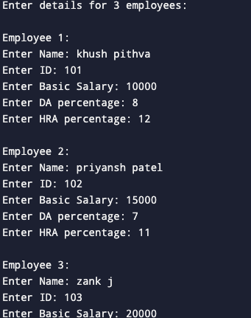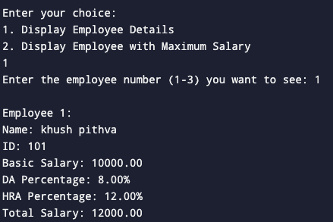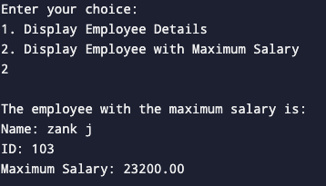
Theoretical Principle: For the first time made structures to hold store the data of employees.

Practical No:8(b)
Aim:Create a structure for a complex number which has a real part and an imaginary part. Add the 2 complex numbers, store it in another complex number using a user defined function and display the result as a complex number.

Methodology Followed:

#include<stdio.h>

struct complex {
float re, im;
};

int main() {
struct complex num[2];
float sum_re, sum_im;

printf("Enter real part of first number: ");
scanf("%f", &num[0].re);
printf("Enter imaginary part of first number: ");
scanf("%f", &num[0].im);

printf("Enter real part of second number: ");
scanf("%f", &num[1].re);
printf("Enter imaginary part of second number: ");
scanf("%f", &num[1].im);

sum_re = num[0].re + num[1].re;
sum_im = num[0].im + num[1].im;

printf("The sum of the two complex numbers is %.2f + %.2fj\n", sum_re, sum_im);

return 0;
}
Input/Output:
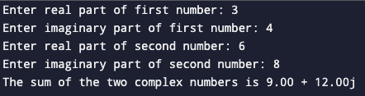
Theoretical Principle: Used structures to perform arithmetic operations on complex numbers.
Conclusion: A structure, also known as a struct, is a user-defined data type that groups related variables of different data types into a single entity

